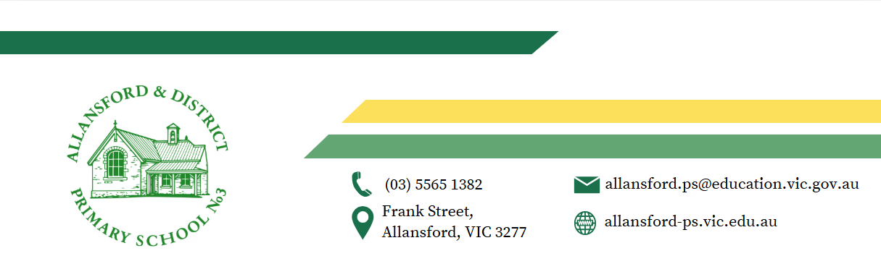

24/11/2025

Dear Parent/Guardian,

Allansford & District Primary School is looking forward to another great year of teaching and learning and would like to advise you of Allansford & District Primary School’s voluntary financial contributions for 2026.
Schools provide students with free instruction to fulfil the standard Victorian Curriculum and we want to assure you that all contributions are voluntary. Nevertheless, the ongoing support of our families ensures that our school can offer the best possible education and support for our students. We want to thank you for all your support, whether that’s through fundraising or volunteering your time. This has made a huge difference to our school and the programs we can offer.
Within our school this valued support has allowed us to:
- Provide excellent quality class materials and resources
- Offer a wide range of subjects and special curriculum experiences for our students across all year levels
- Offer exemplary programs such as STEAM, Art, Japanese and PE
- Enhance our core learning in Literacy and Numeracy and maintain ongoing educational subscriptions.
Department of Education guidelines now mandate that schools are UNABLE to provide parents with a statement of fees. With this in mind, parents are asked to please review the recommended voluntary financial contributions schedule below for an indication of contributions for your child/ren.

For further information on the Department’s Parent Payments Policy please see a one-page overview attached.

Yours sincerely,

Gavin Young Matthew Adams
Principal School Council President

Student Name: Grade:

Curriculum Contributions - items and activities that students use, or participate in, to access the Curriculum | Amount
Classroom consumables, materials & equipment  - Student Requisites-stationery, writing books, scrap books, book boxes, take home readers, laminating  - Craft Activities – paint, crayons, canvas, glitter, coloured paper, glue, card, wool, material, beading  - Printing and photocopying of worksheets and learning materials | $75  $15
STEAM  - Tape, glue, paper, Sphero’s, Goods for experiments | $5
ART  - Paints, Coloured Card & Art paper, Brushes, Charcoal, Crayons. | $10
Japanese Studies  - Origami paper, Calligraphy brushes, pencils, glue sticks  - Cooking & special activities, Festival craft supplies & Sushi making (or similar) | $5
Online Subscriptions  - Sunshine Books  - Diebels- M Class  - Compass | $35
- Water Safety Program- Bus & Entry | $85
Other Contributions - for non-curriculum items and activities | Amount
- School Sports/Cross Country – entry/venue hire and transport & School Sports Affiliation $10  - Incursion/Excursions – entry and transport $60 | $70
Total Amount | $300

Educational items for students to own
ADPS recommends you purchase class materials through ADPS for your child to individually own and use. ADPS buys in bulk allowing us to purchase the best quality items cheaply and maintaining the same standard of class requisites per student.
If you would like to purchase an item for your child, please indicate on the table below under voluntary Curriculum contributions and return this to the school by the 17th December 2025. No payment is required for these items until 2026.

Extra-Curricular Items and Activities
ADPS offers a range of items and activities that enhance or broaden the schooling experience of students and are above and beyond what the school provides in order to deliver the Curriculum. These are provided on a user-pays basis.
ADPS seeks to keep the cost to parents for camps & extra activities as low as possible. Below is a guide to what these costs may be in 2025. Permission forms and payment requests will be sent out to families throughout 2025 for any extra-curricular camps or activities.
Student Name: Grade:
Extra-Curricular Items and Activities | Amount
The costs below are only an estimate
Clubs- Payment based on student choice of activity | TBA
Foundation – Day Out | $20
Year 1- Big Day Out | $30
Year 2- Sleepover & Big Day Out | $40
Year 3 & 4- Camp | $220
Year 5 & 6- Camp | $350
Total Extra-curricular Items and Activities

Financial Support for Families
Allansford & District Primary School understands that some families may experience financial difficulty and offers a range of support options, including:
- Camps, Sports and Excursions Fund to eligible Health Care Card holders (CSEF)
- Individual Payment Plans
- State School Relief
For a confidential discussion about accessing these services, or if you would like to discuss alternative payment arrangements or a Payment Plan, please contact our Business Manager:
Andrea Lyon
Ph: 03 5565 1382| Email: allansford.ps@education.vic.gov.au

Student Name: Grade:
Total
Category
Curriculum Contributions | $
Other Contributions | $

Payment methods
Parent contributions towards the requested payments is essential to maintain the quality of education we provide at Allansford & District Primary School.
At ADPS we offer Payment Plans. Some parents find these especially helpful towards Camp costs. Any monies left over can either be kept as a credit for the following year or refunded to you.

You can make payment in 2026 as per below:

Direct Deposit: ADPS BSB: 063-533 A/C: 00900451.

Office: EFTPOS or Cash

BPay: Your unique BPay identifier will be provided to you on request

Refunds

Parent requests for refunds are subject to the discretion of the school and made on a case-by-case basis. Refunds will be provided where the school deems it is reasonable and fair to do so, taking into consideration whether a cost has been incurred, the Department’s Parent Payment Policy and Guidance, Financial Help for Families Policy and any other relevant information.]

parent PAYMENTS policy

ONE PAGE OVERVIEW
 | FREE INSTRUCTION  - Schools provide students with free instruction and ensure students have free access to all items, activities and services that are used by the school to fulfil the standard curriculum requirements in Victorian Curriculum F-10, VCE and VCAL.  - Schools may invite parents to make a financial contribution to support the school.

 | PARENT PAYMENT REQUESTS  Schools can request contributions from parents under three categories:  - Schools may also invite parents to supply or purchase educational items to use and own (e.g. textbooks, stationery, digital devices).
  Curriculum Contributions  Voluntary financial contributions for curriculum items and activities which the school deems necessary for students to learn the Curriculum. | Other  Contributions  Voluntary financial contributions for non-curriculum items and activities that relate to the school’s functions and objectives. | Extra-Curricular Items and Activities  Items and activities that enhance or broaden the schooling experience of students and are above and beyond what the school provides for free to deliver the Curriculum. These are provided on a user-pays basis.

 | FINANCIAL HELP FOR FAMILIES  - Schools put in place financial hardship arrangements to support families who cannot pay for items or activities so that their child doesn’t miss out.  - Schools have a nominated parent payment contact person(s) that parents can have a confidential discussion with regarding financial hardship arrangements.

 | SCHOOL PROCESSES  - Schools must obtain school council approval for their parent payment arrangements and publish all requests and communications for each year level on their school website for transparency.

